**KAFKA**

1.Install kafka and set the path in the environment variable

2. Try to run zookeeper. If we get error, then we must delete class path from environment variable

3. start zookeeper

To start zookeeper, we need to go the config folder and run the bat command

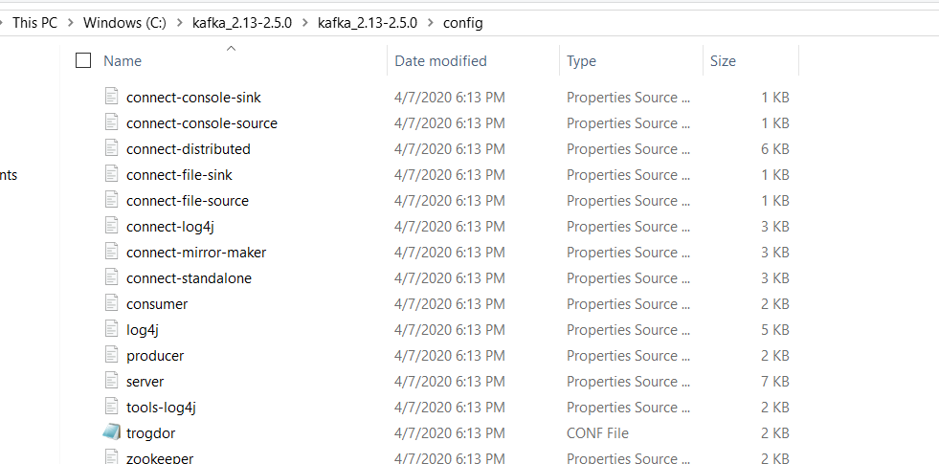

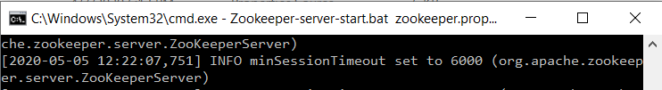

**Zookeeper-server-start.bat zookeeper.properties**

5. Start kafka server

**Kafka-server-start.bat server.properties**

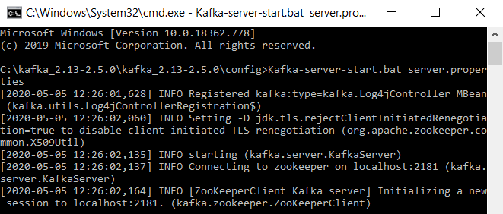

6.Create a topic



List kafka topics

**Kafka-topics.bat --list -bootstrap-server localhost:9092**



7.Create kafka producer and publish to the topic which we created

9092 is our kafka broker

**Kafka-console-producer.bat --broker-list localhost:9092 --topic first_kafka_topic**

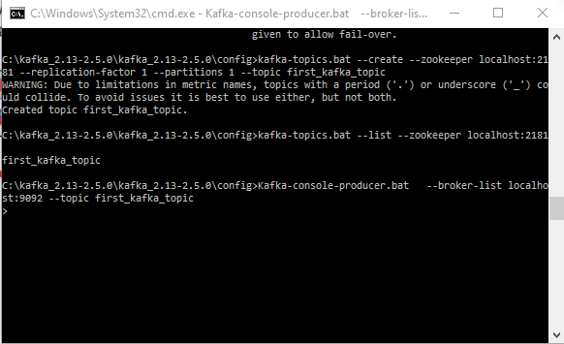

8. Create kafka consumer.

Note 1) We need to specify the bootstrap server.

we need message from the beginning.

**Kafka-console-consumer.bat --bootstrap-server localhost:9092 --topic first_kafka_topic --from-beginning**

**Output**



**KAFKA TWEET PRODUCER**

In this example we would be using a kafka producer to stream tweets.

Note:

* Here we are streaming the tweets from twitter to kafka producer
* We need to set up the tweets listener
* Tweets are received in the form of JSON
* We load the data to a python dictionary
* Split tweets into individual words and find the tweets which has hashtag

1. We need to run all the services including zookeeper, brokers, producers, and consumers.
2. We then need start the tweet listener

**Python Kafka_twitter.py localhost 9092 first_kafka_topic “world cup”**

Output

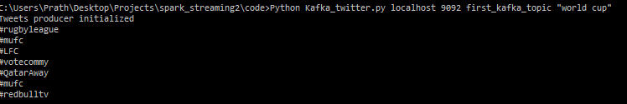

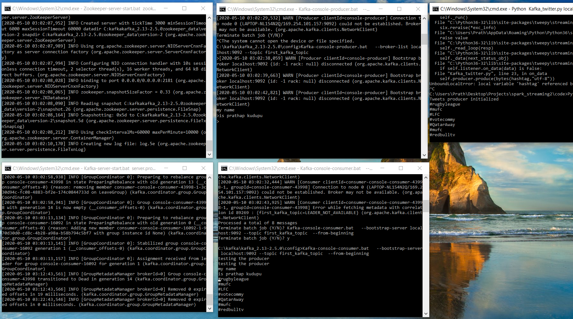

We can see that that the consumer which has subscribed to the topic is receiving the data from the tweet listener

**KAFKA SENTIMENT ANALYSIS**

* Use kafka producer with tweet
* Analyze tweet sentiment using afinn (We can do sentiment analysis on text without using any machine learning)
* Entire message would be sent

1. We need to run the zookeeper, kafka brokers, producers
2. Start the tweet listener

**Python kafka_twitter_sentiment_analysis.py localhost 9092 first_kafka_topic “world cup”**

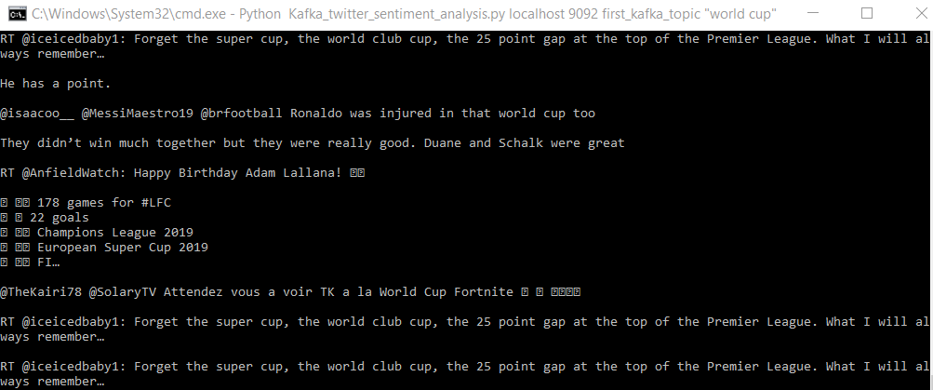

1. Specify the dependencies that the spark would use

**spark-submit --packages org.apache.spark:spark-sql-kafka-0-10_2.12:2.4.5\ sentiment_analysis_streaming.py localhost 9092 first_kafka_topic**

Output